Economics Examination

IMPORTANT INFORMATION FOR TEACHERS

This examination is designed to assess student learning from a sample of Economics related Year 10 content from the K-10 Society and Environment Syllabus. This content is drawn from the Resources and Natural and Social Systems outcomes. Relevant prior learning for the senior secondary Economics course was also considered in the development of the exam.

The exam is provided as a sample that teachers can modify and adapt as they see fit. It is recognised that a variety of content is studied in Year 10 Society and Environment classrooms across the state. Therefore, teachers using this exam should carefully review it and consider amendments that reflect the specific learning experiences and/or characteristics of their students.

Results from this examination can be used within and between schools for evaluative, comparative and diagnostic purposes. However, it must be recognised that any student achievement information provided by this exam only represents a portion of the total evidence teachers will use in assessing overall student performance in the Society and Environment Learning Area. Similarly, it should only be used as one point of reference for considering the preparedness of students for the senior secondary Economics course.

Some SUGGESTED topics for question 5 – an Australian or World economic issue:
- Globalisation of the Australian economy
- Achieving a sustainable economy
- Economic growth (The costs vs. the benefits)
- The introduction of an Emissions Trading Scheme
- Sending jobs off shore
- Privatisation vs government supply of collective goods and services

(SCHOOL NAME)

Department of Society and Environment

Year 10 Exam

ECONOMICS
ECONOMIC SYSTEMS
RESOURCES

EXAM CONDITIONS

Completion Requirements

This exam consists of six (6) questions in two sections

SECTION A: Two (2) questions
Answer ONE question
Both questions in Section A are worth twelve (12) marks.

SECTION B: Four (4) questions
Answer ANY TWO questions
All questions in Section B are worth 14 marks
Marks allocated to each task in all question are listed with the task.

TOTAL MARKS FOR THIS EXAMINATION: 40 marks

Time Allowed For This Exam

Reading Time: 5 Minutes
Working time: 60 Minutes

SECTION A

Answer EITHER Question 1 OR Question 2

Question 1 12 Marks
Study extract 1 to complete your responses to question 1.

Extract 1

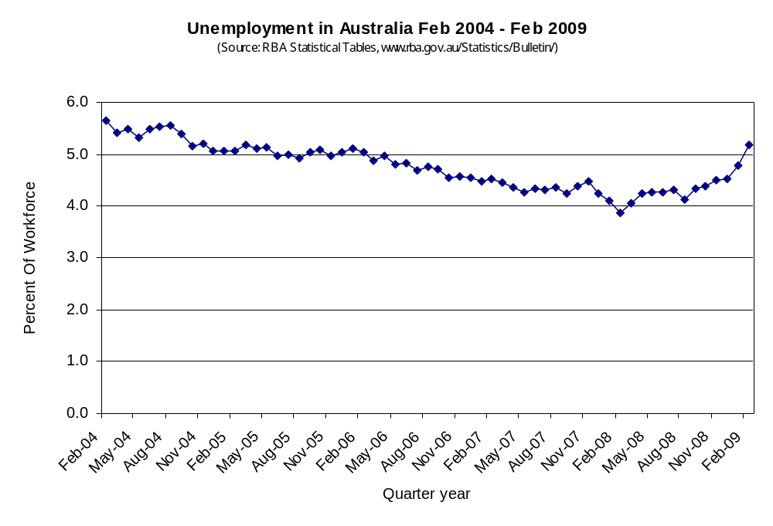

- Define the term “unemployment”. (1)

_____________________________________________________________________________
_____________________________________________________________________________
- From the information for the period shown in Extract 1,
  - when did Australia experience its lowest rate of unemployment? _______________ (1)

  - what has been the highest rate of unemployment in Australia? _______________ (1)

- Of the main causes (types) of unemployment, which is most likely to be the cause
of the recent rise in unemployment shown on the graph? Explain the reason for your
conclusion. (3)

_____________________________________________________________________________
_____________________________________________________________________________
_____________________________________________________________________________

_____________________________________________________________________________
_____________________________________________________________________________
_____________________________________________________________________________

_____________________________________________________________________________
- What are the main social and economic effects of high rates of unemployment in
an economy? (3)

_____________________________________________________________________________
_____________________________________________________________________________
_____________________________________________________________________________

_____________________________________________________________________________
_____________________________________________________________________________
_____________________________________________________________________________

_____________________________________________________________________________
- Describe what a government can do to help overcome the problems of unemployment in an
economy? (3)

_____________________________________________________________________________
_____________________________________________________________________________
_____________________________________________________________________________

_____________________________________________________________________________
_____________________________________________________________________________
_____________________________________________________________________________

_____________________________________________________________________________

Question 2 12 marks

A person needs to take a number of factors into consideration when planning to enter
the work force. Based on your own experience of this decision, complete the following.

- List three factors that have affected, or will affect, your career decision (1.5)

_____________________________________________________________________________
_____________________________________________________________________________
_____________________________________________________________________________

- List three factors that will influence your ability to pursue your chosen career. (1.5)
_____________________________________________________________________________
_____________________________________________________________________________
_____________________________________________________________________________
_____________________________________________________________________________
- Identify the difference between Income and Wealth. (2)

_____________________________________________________________________________
_____________________________________________________________________________
_____________________________________________________________________________
_____________________________________________________________________________

At times a number of people in an economy will find themselves unemployed. Write your answers to questions 2 d), 2 e) and 2 f) in the spaces below.

- Describe ONE positive and ONE negative effect on the level of unemployment of
introduction of new technology in the workplace (2)
_____________________________________________________________________________
_____________________________________________________________________________

_____________________________________________________________________________
_____________________________________________________________________________
_____________________________________________________________________________

- List TWO effects unemployment has on the people who become unemployed. (2)

_____________________________________________________________________________
_____________________________________________________________________________
_____________________________________________________________________________

_____________________________________________________________________________
_____________________________________________________________________________

- List THREE effects unemployment has the general level of economic activity. (3)

_____________________________________________________________________________
_____________________________________________________________________________
_____________________________________________________________________________

_____________________________________________________________________________
_____________________________________________________________________________

_____________________________________________________________________________
_____________________________________________________________________________

SECTION B
Complete ANY TWO of questions 3, 4, 5 or 6.

Question 3 (14 Marks)
Use the information in the table and the graph below to complete your responses to this question.

Answer questions 2 a), 2 b) and 2 c) on the graph below.

- On the graph, print all missing labels for the graph. (2)

SEASONAL MARKET FOR UMBRELLAS

Price | Demand (Per Week) |  | Supply
Price | Winter | Summer | Supply
$2 | 300 | 77 | 2
$4 | 270 | 67 | 31
$6 | 240 | 60 | 60
$8 | 210 | 55 | 90
$10 | 180 | 45 | 120
$12 | 150 | 36 | 150
$14 | 120 | 29 | 180
$16 | 90 | 20 | 209
$18 | 60 | 11 | 239
$20 | 30 | 3 | 265

$20
$18
$16
$14 |  |  |  |  |  |  |  | B
$12
$10
$8
$6
$4
$2
 |  |  |  | A
0 30 60 90 120 150 180 210 240 270 300

- For arrow A on the graph, label what happens to demand for umbrellas as the season
moves from winter into summer. (1)

- For arrow B on the graph, label what happens to the supply of umbrellas as the
price falls. (1)

- Why would shops supply more umbrellas at higher prices? (1)
_____________________________________________________________________________
_____________________________________________________________________________

_____________________________________________________________________________

_____________________________________________________________________________

- At what price will consumers demand 135 umbrellas in winter? _________________ (0.5)

- In winter, at what price(s) will some consumers find that there are no umbrellas available
to buy late in the week? ______________________________________ (0.5)

- What is the equilibrium price of umbrellas:

  - In winter? ______________________________________ (0.5)

  - In summer? ______________________________________ (0.5)

- If a particular shop sells out of umbrellas before the end of a normal week, what is the
likely reaction of the shop owner for selling and pricing umbrellas in the following week?
Explain your answer. (3)

_____________________________________________________________________________
_____________________________________________________________________________
_____________________________________________________________________________

_____________________________________________________________________________
_____________________________________________________________________________
_____________________________________________________________________________
_____________________________________________________________________________
- How will the price at which umbrellas are sold affect the production decisions of umbrella
wholesale suppliers (manufacturers and importers) in the economy? (4)

_____________________________________________________________________________
_____________________________________________________________________________
_____________________________________________________________________________

_____________________________________________________________________________
_____________________________________________________________________________
_____________________________________________________________________________

_____________________________________________________________________________
_____________________________________________________________________________
_____________________________________________________________________________

_____________________________________________________________________________
_____________________________________________________________________________
_____________________________________________________________________________

_____________________________________________________________________________
_____________________________________________________________________________

Question 4 (14 Marks)

- List FOUR sources of finance available to people wishing to borrow money for purchases. (2)

_____________________________________________________________________________
_____________________________________________________________________________
_____________________________________________________________________________

_____________________________________________________________________________

- For ONE of the sources you have listed in part a) of this question, list the advantages and disadvantages of each source of money in the tables below. (4)

Source:
Advantages | Disadvantages

- List FOUR methods a person earning an income can use to increase their long-term wealth, including making provision for having enough money in retirement. (2)

_____________________________________________________________________________
_____________________________________________________________________________

_____________________________________________________________________________
_____________________________________________________________________________

- List FOUR methods used by the Australian government to ensure there is a reasonably
fair distribution of wealth amongst the people of Australia. (2)

_____________________________________________________________________________
_____________________________________________________________________________

_____________________________________________________________________________
_____________________________________________________________________________

- For ONE of the methods listed above, explain how the action improves the fairness of wealth distribution in Australia. (4)
_____________________________________________________________________________
_____________________________________________________________________________
_____________________________________________________________________________
_____________________________________________________________________________
_____________________________________________________________________________

_____________________________________________________________________________
_____________________________________________________________________________
_____________________________________________________________________________
_____________________________________________________________________________

Question 5 (14 Marks)

For an Australian or world economic issue studied, complete the following:

- Outline the nature of the issue, highlighting the economic problem forming the basis of
the issue. (4)
_____________________________________________________________________________
_____________________________________________________________________________

_____________________________________________________________________________
_____________________________________________________________________________
_____________________________________________________________________________
_____________________________________________________________________________

_____________________________________________________________________________
_____________________________________________________________________________
- Explain the effect(s) of the issue on the Australian economy in recent times. (4)
_____________________________________________________________________________
_____________________________________________________________________________

_____________________________________________________________________________
_____________________________________________________________________________
_____________________________________________________________________________

_____________________________________________________________________________
_____________________________________________________________________________
- Describe the government’s response to the issue and explain why the government has
responded this way. (6)
_____________________________________________________________________________
_____________________________________________________________________________

_____________________________________________________________________________
_____________________________________________________________________________
_____________________________________________________________________________
_____________________________________________________________________________

_____________________________________________________________________________
_____________________________________________________________________________
_____________________________________________________________________________
_____________________________________________________________________________

_____________________________________________________________________________
_____________________________________________________________________________
_____________________________________________________________________________
_____________________________________________________________________________

_____________________________________________________________________________
_____________________________________________________________________________
_____________________________________________________________________________
_____________________________________________________________________________

_____________________________________________________________________________

Question 6 (14 Marks)

- Briefly describe Australia’s links to other economies in the world through trade OR aid.
(4)

_____________________________________________________________________________

_____________________________________________________________________________
_____________________________________________________________________________
_____________________________________________________________________________
_____________________________________________________________________________
_____________________________________________________________________________
_____________________________________________________________________________
_____________________________________________________________________________
_____________________________________________________________________________
- Describe the advantages that result from EITHER trade OR aid

  - for Australia (3)

_____________________________________________________________________________

_____________________________________________________________________________
_____________________________________________________________________________

_____________________________________________________________________________
_____________________________________________________________________________
_____________________________________________________________________________
_____________________________________________________________________________

  - the countries with which Australia deals (3)

_____________________________________________________________________________
_____________________________________________________________________________
_____________________________________________________________________________
_____________________________________________________________________________
_____________________________________________________________________________
_____________________________________________________________________________
_____________________________________________________________________________

Briefly explain the effects of the globalisation of the world economy on the Australian
economy. (4)

_____________________________________________________________________________
_____________________________________________________________________________
_____________________________________________________________________________
_____________________________________________________________________________
_____________________________________________________________________________
_____________________________________________________________________________
_____________________________________________________________________________
_____________________________________________________________________________

_____________________________________________________________________________
_____________________________________________________________________________

END OF EXAMINATION

